**Object in JavaScript**

* An object is a complex data type that allows us to store and organize data in key-value pairs. Objects can be representing real world entities and are used to model and manipulate information efficiently.

**Creating Objects in JS**

* Objects in JavaScript can be created using object literals or the Object constructor.

//Object Literal

var student = {

//properties

name: 'Dasvin',

age: 23,

Id: 2404

};

//Object constructor

function studentDetail(name, age, id){

this.name = name;

this.age = age;

this.id = id;

}

let MystudOne = new studentDetail("Dasvin", 23, 2404)

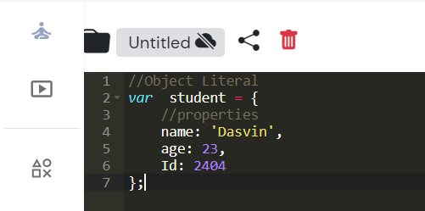

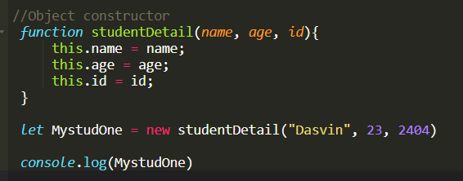

Here student and studentDetail are objects with properties ‘name’, ‘age’ and ‘id’.

**Internal representation of Object**

* The internal representation of JS varies between different JS engines (e.g., V8, spider monkey, JavaScriptCore).

Properties table:

* JS typically use a properties table to store the properties of an object. Each entry in the table consists of key-value pair, where the key is a property name-usually a string and the value is a reference to the property’s value.

Hidden classes (or shapes):

* Some JavaScript engines, like V8, use hidden classes (also known as shapes or maps) to optimize property access. Hidden classes define the layout of objects and their properties, allowing the engine to optimize property access by grouping objects with similar shapes together. When you add or remove properties from an object, the engine may create a new hidden class for the object if its shape changes significantly.

Prototype Link:

* Each object has an internal property called [[Prototype]] that points to another object, known as its prototype. This forms the basis for the prototype chain, which is used to implement inheritance in JavaScript.

Methods:

* Methods are typically stored as properties of an object, where the property value is a reference to the function associated with the method.

Primitive Values vs. Object References:

* Properties can store either primitive values (e.g., Numbers, Strings, Booleans) directly or references to other objects. When an object contains a property with a primitive value, the value is stored directly in the properties table. When an object contains a property with an object reference, the reference is stored in the properties table.

Garbage Collection:

* JavaScript engines automatically manage memory, including reclaiming memory occupied by objects that are no longer reachable. Garbage collection algorithms vary between JavaScript engines but typically involve identifying and reclaiming memory that is no longer in use.